Assignment-11.1:

Write the Pig codes to analyze the petroleum data set.

1.) What is the total amount of petrol in volume sold by every distributor?

Pig Script:

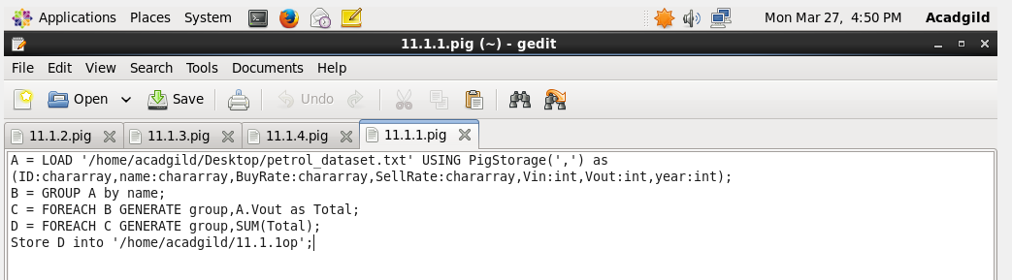

Executing the Pig Script:

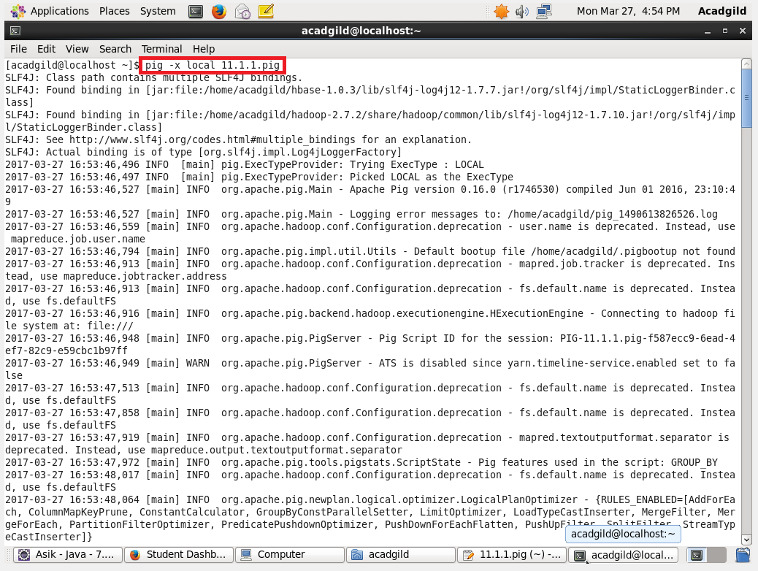

Output:

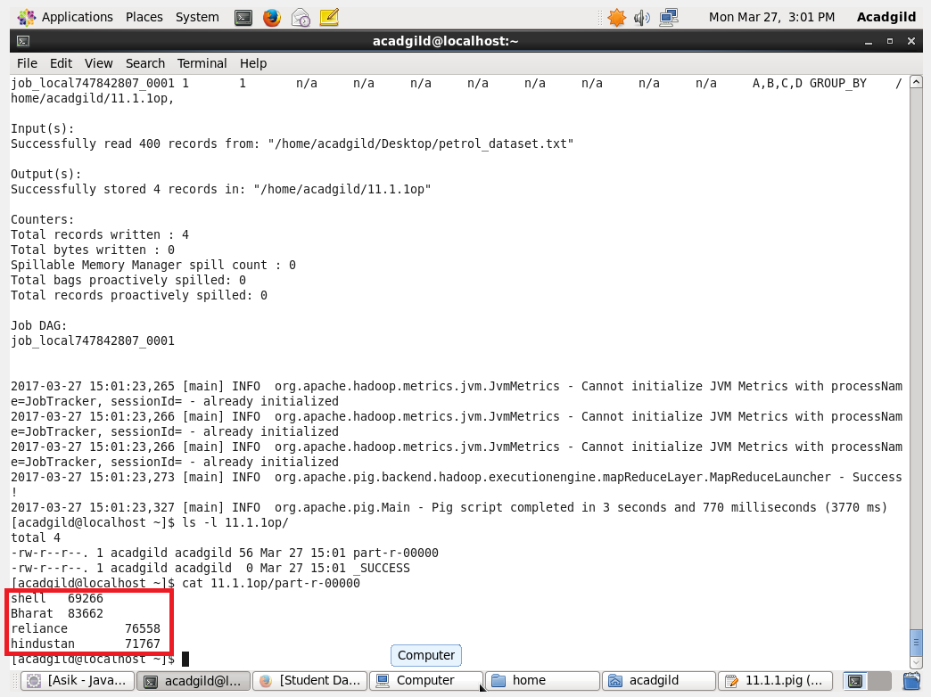

2.) Which are the top 10 distributors ID's for selling petrol? Also display the amount of petrol sold in volume.

Pig Script:

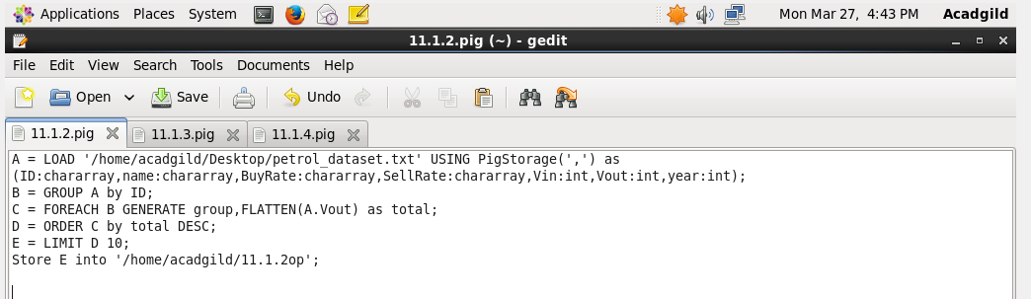

Executing the Pig Script:

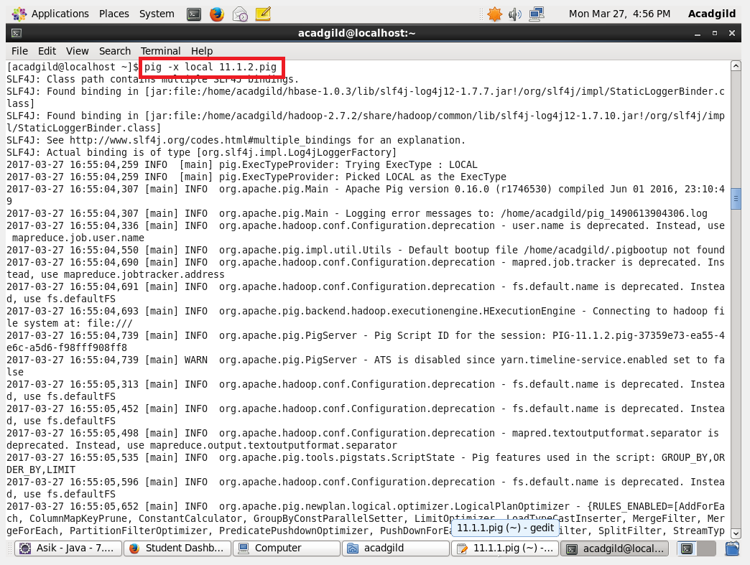

Output:

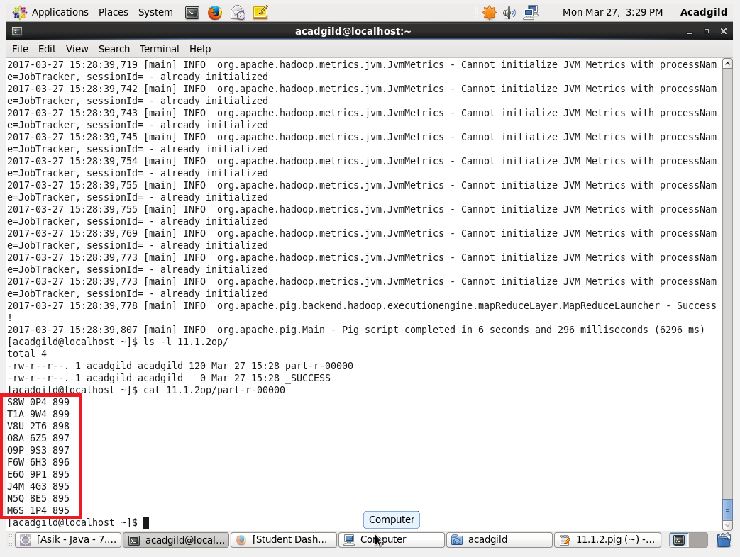

3.) List 10 years where consumption of petrol is more with the distributer id who sold it

Pig Script:

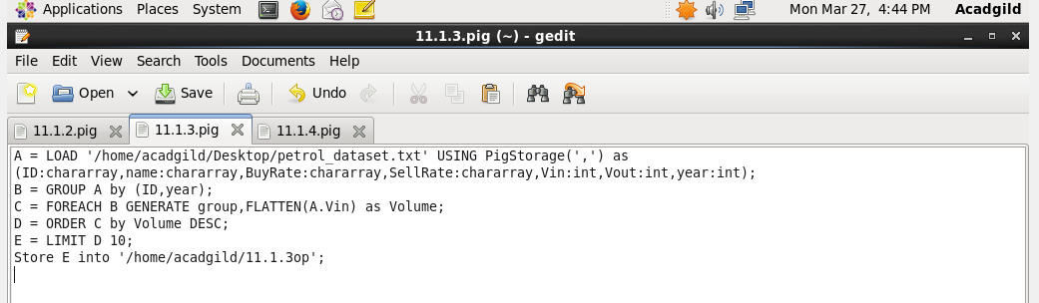

Executing the Pig Script:

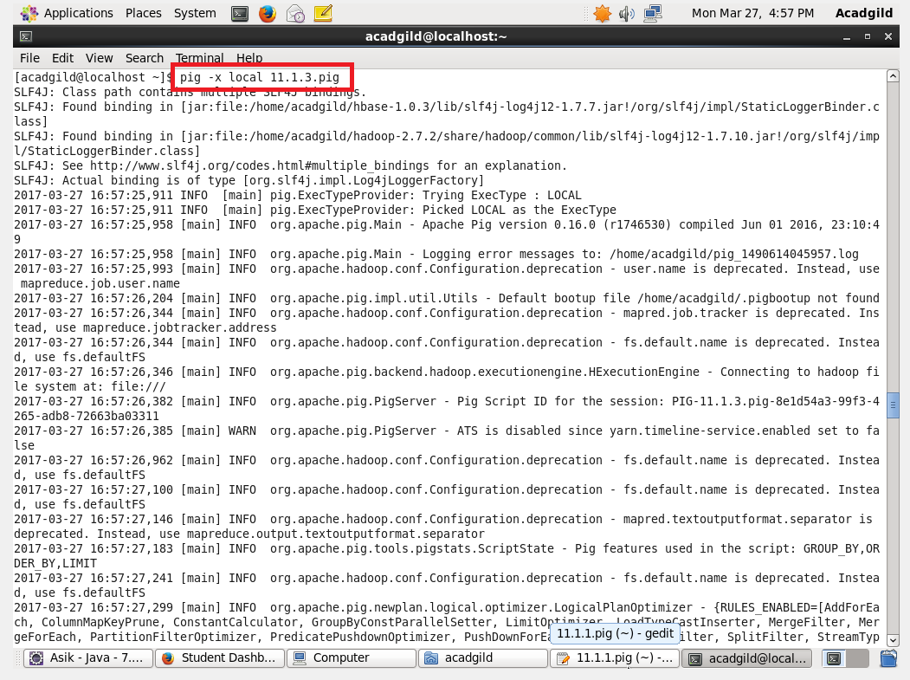

Output:

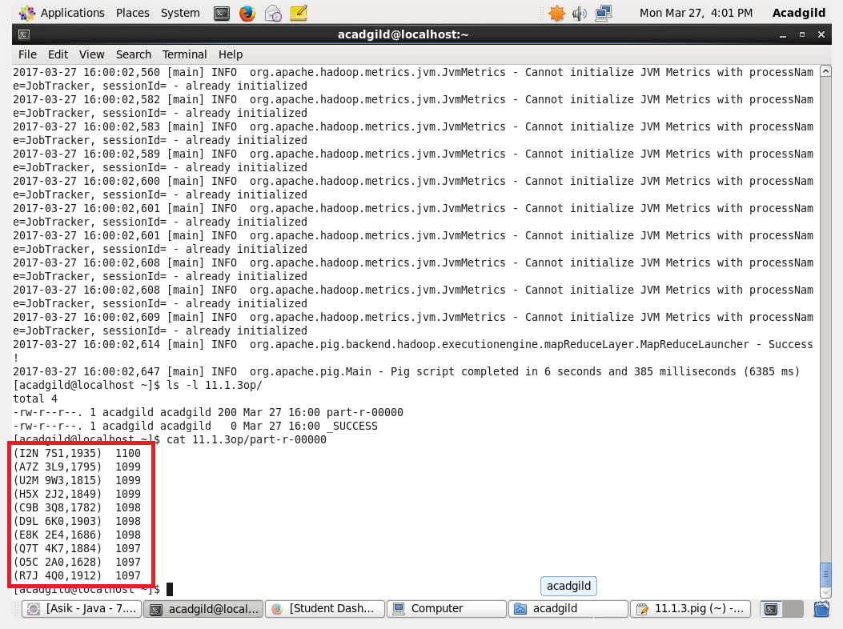

4. )Find the distributer name who sold petrol in least amount.

Pig Script:

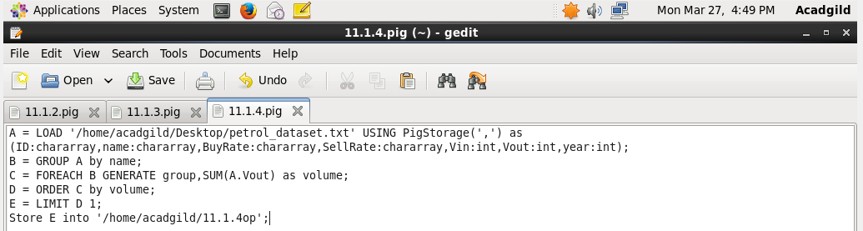

Executing the Pig Script:

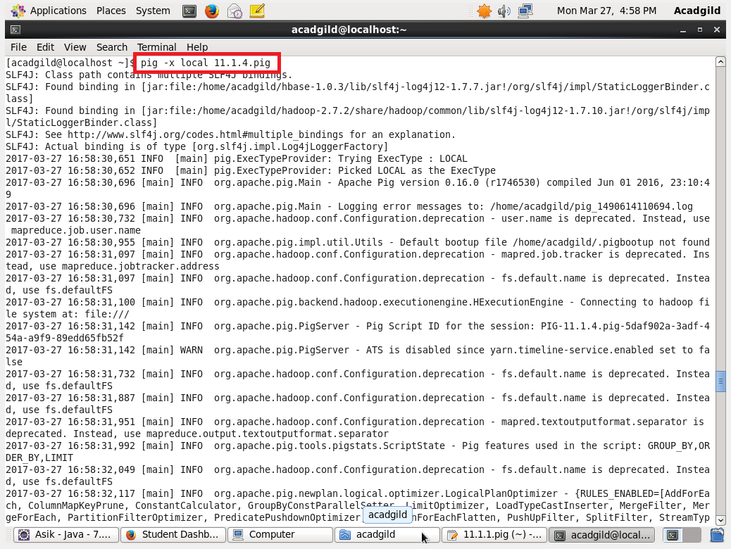

Output:

